Assignment 2
1. Write a program to find the factorial of a number.
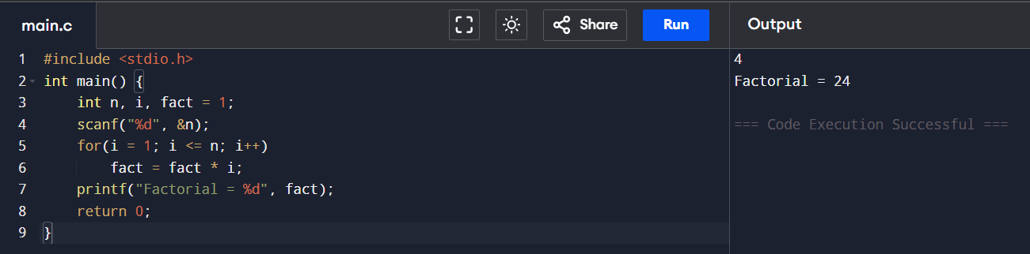

2. Write a program to calculate the sum of digits of a number.
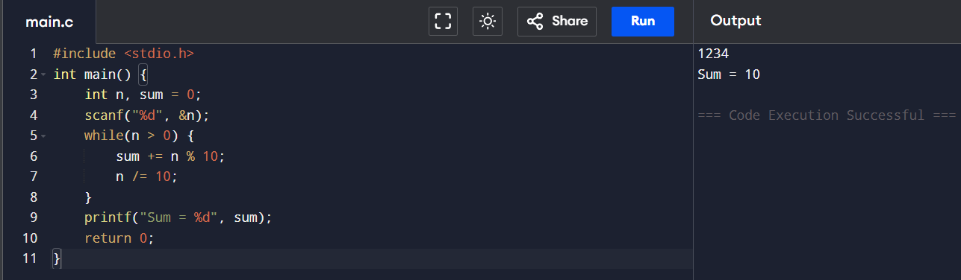

3. Write a program to reverse a number.
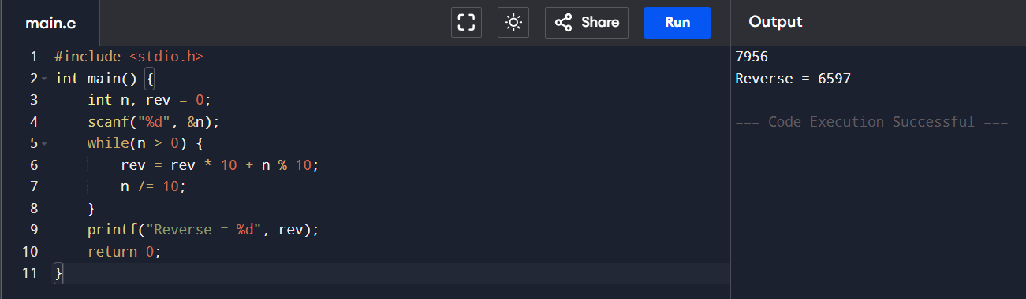

4. Write a program to check whether a number is a palindrome.
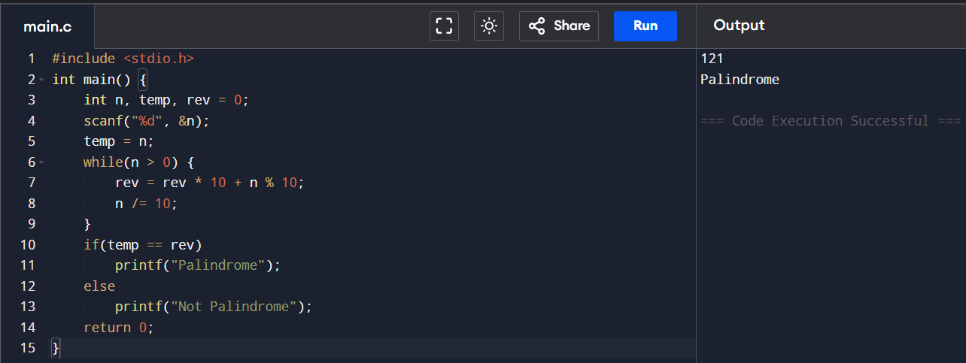
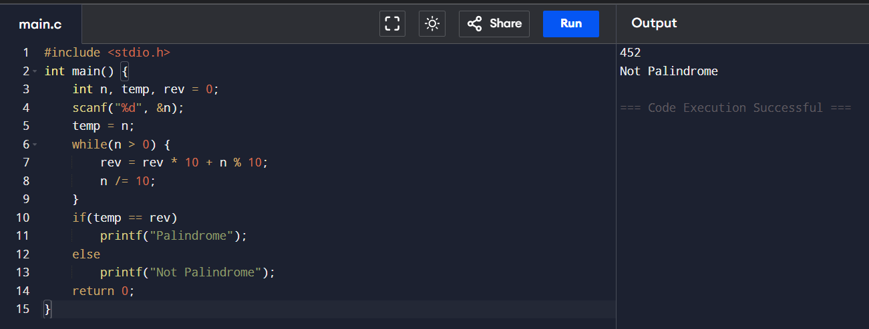

5. Write a program to print multiplication table of a number.
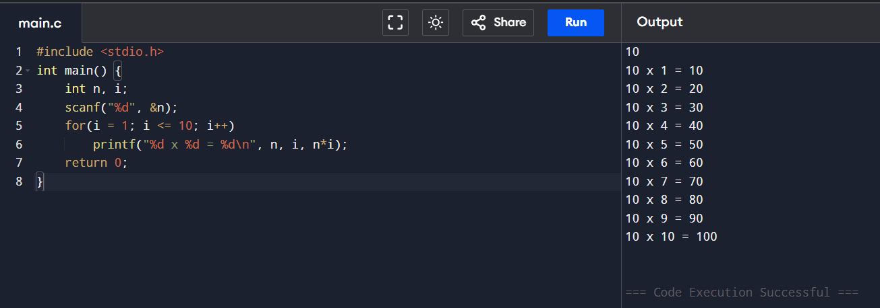

6. Write a program to count the number of digits in a number.
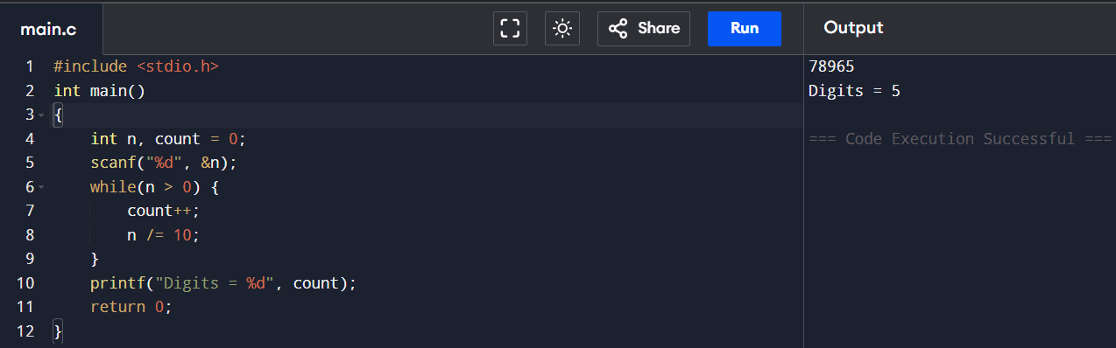

7. Write a program to print the Fibonacci series up to n terms.
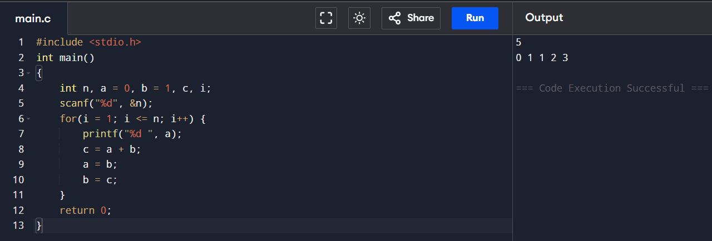

8. Write a program to calculate the sum of the series 1/1!+2/2!+3/3!.......1/n!
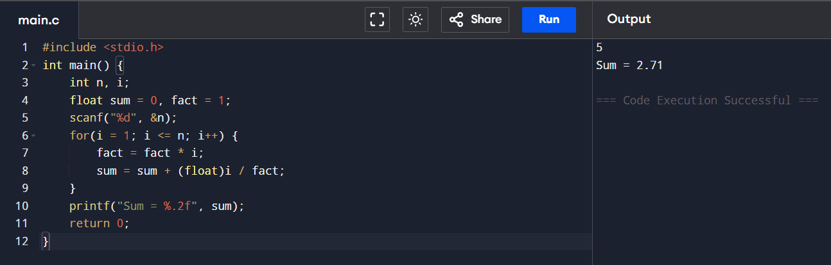

8. Write a program to find the absolute value of a number.
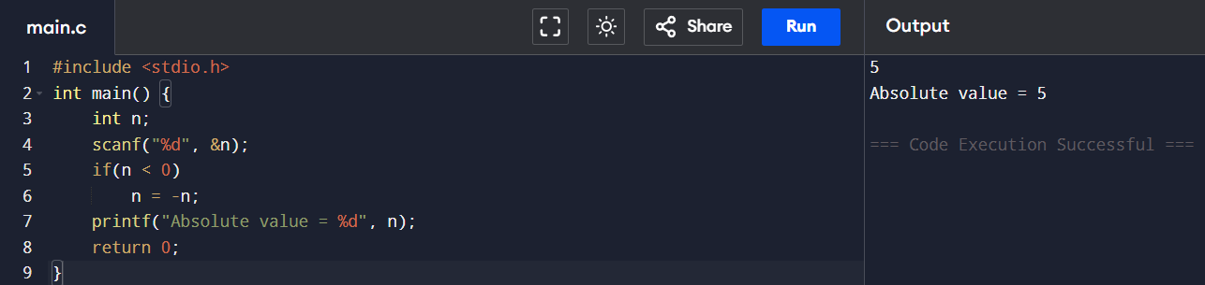
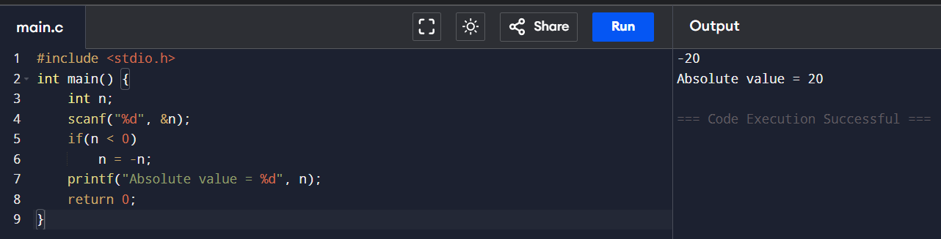

9. Write a menu-driven program to perform +, -, *, / operations.
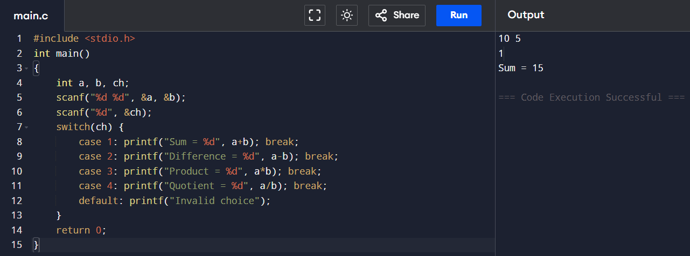
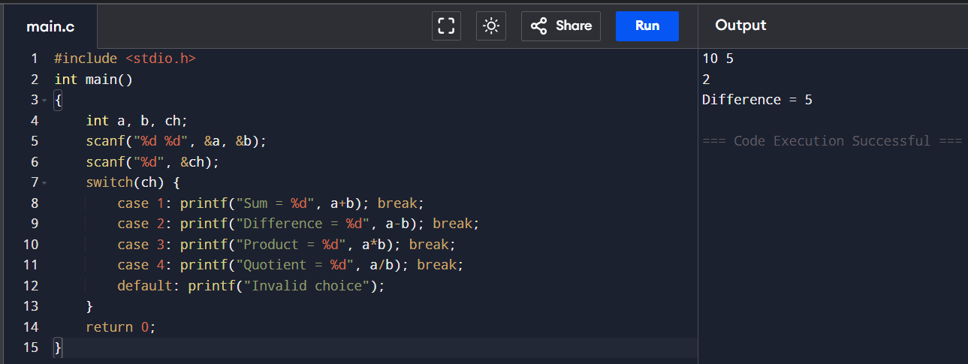
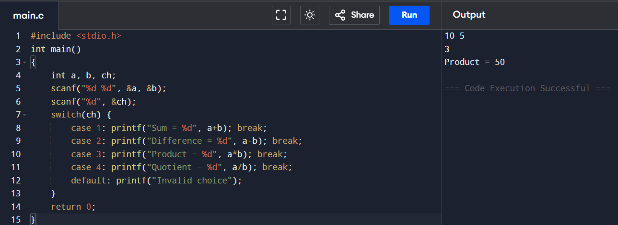
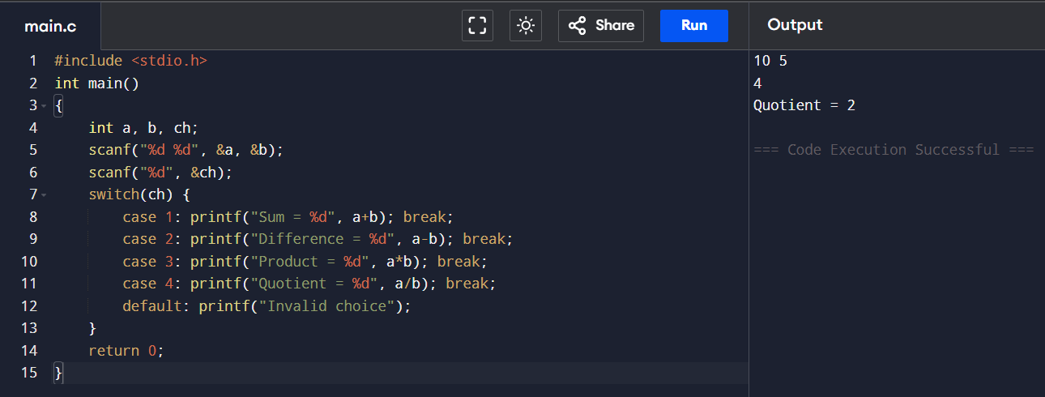

10. Write a program to find roots of a quadratic equation. 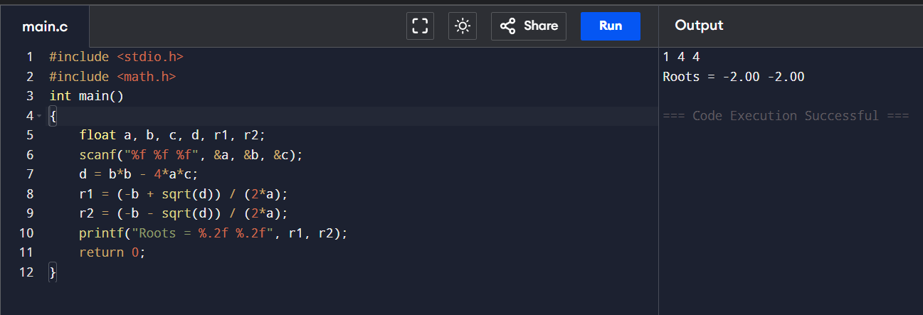
11. Write a program to check whether a number is an Armstrong.
